**Progress Report**

Muhammad Suleman, Asjid Ahmed

[P176147@nu.edu.pk](mailto:P176147@nu.edu.pk), [p176124@nu.edu.pk](mailto:p176124@nu.edu.pk)

**Supervisor:**

Faculty Member’s Name: Mr. Zeshan Khan Signature: ___________________

Date: (26th February 2022)

# Abstract:

Review Based Analysis plays a very important role in mobile selection. Many techniques exist for the analysis of mobile phones. But feature based analysis and fake reviews detection requires understanding the context and the actual meaning of the words. Two reviews, conveying same message, can be written quite differently. The review analysis requires human intelligence and effort. We propose an automatic review analyser application that analyses and gives the top suggestions. The system based on the artificial intelligence will verify the reviews and allocate rating accordingly. In the end, the evaluation is done to prove that our approach gives much realistic behaviour and can be used by the buyers as well as the sellers.

# Timeline:

The timeline for milestones of FYP-II

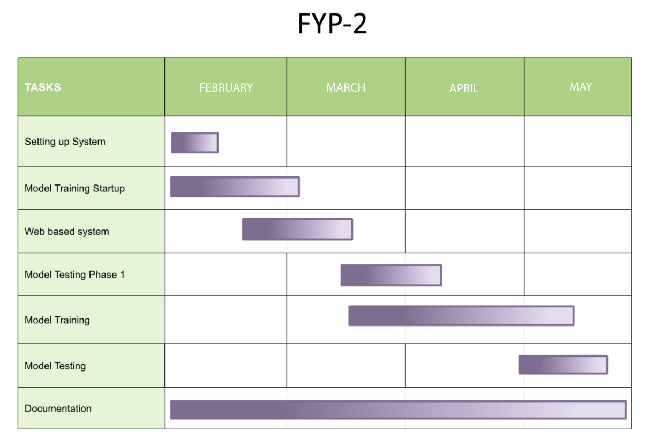

# Progress FYP-I Final

Sentiment Analysis has different parts which includes data scraping, data pre-processing, model training, sentence level analysis, features level analysis, results visualization, evaluation.

Progress/Milestones achieved:

1. Data Scraping.
2. Data Pre-processing.
3. Model Training.

# FYP-II Milestone

Following are the FYP-II Milestones:

1. Sentence Level Analysis.
2. Features Level Analysis.
3. Results Visualization.
4. Evaluation.
5. Final Product.